Augmented Reality Indoor navigation System – Study Report

# References to explore:

* <https://www.fantasmo.io/> - Fantasmo
* <https://www.pozyx.io/> - Pozyx
* <http://wifarer.com/> - Wifarer

# 

# **Fantasmo:**

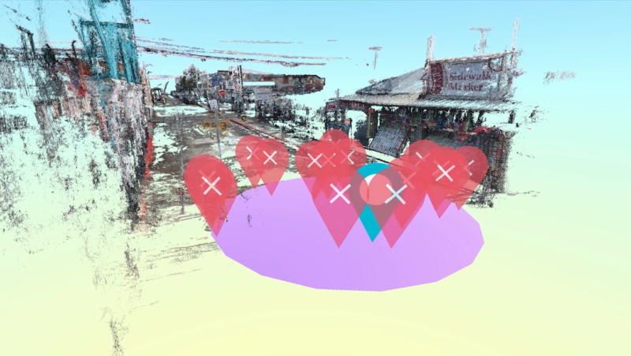 Fantasmo is a team based out of Greater Los Angeles area, who introduced a new concept on mapping services for mobile & robots based on photogrammetry geospatial data. They named it as **“CPS”**, whereas CPS stands for **“Camera Position Standard”**. This allows developer contribute to and draw from a sub-centimetre accuracy map for robot navigation or anchoring AR experiences. 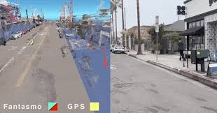

# **Pozyx:**

Pozyx is a hardware/software based positioning system which uses a unified hardware with its own companion software made by Pozyx team. This uses Ultra-wideband technology (UWB) to ranging and positioning. Which is also capable to use Wi-Fi, Bluetooth beacons for more accuracy.

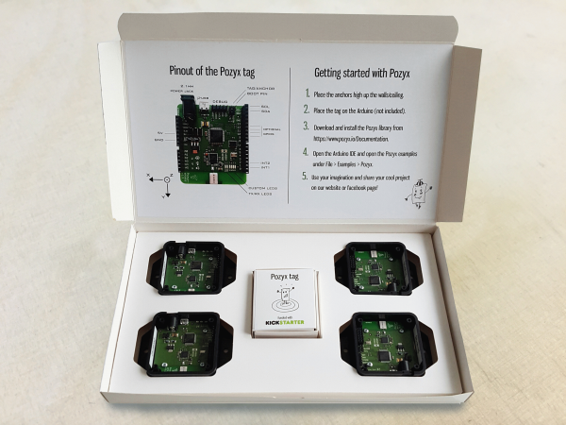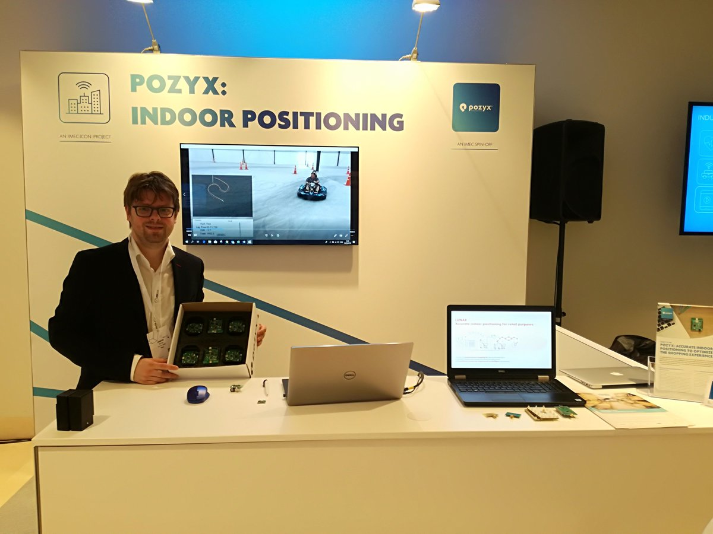

# **Wifarer:**

Wifarer is an Indoor LBS (location Based Service) SDK, which uses the RF, Wi-Fi, Bluetooth beacons for indoor navigation. Wifarer provides an online CMS which enables the developers to create and manage content for their indoor positioning app.

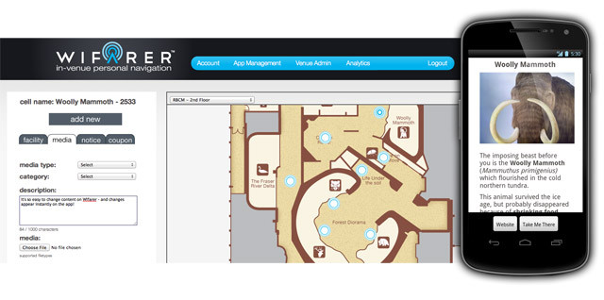

# **Additional Data and Open Source packages:**

**1. Indoor Real Time Navigation with SLAM on mobile**

Using the SLAM technology the indoor navigation can be achieved with 1-2 cm error. This could be done by combining Google ARCore SDK and SLAM SDK tools with Unity or Unreal.

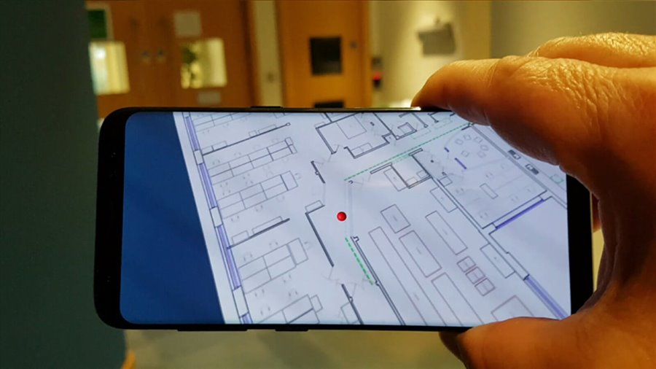

**2. Droid AR**

DroidAR is a mobile location based augmented reality framework and it is completely open source available on github. Which enables location based AR and Marker based AR in android devices.

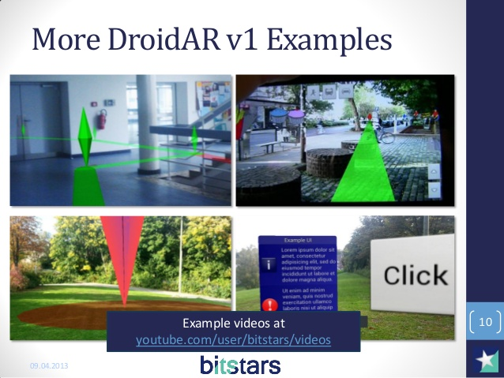

**3. ARToolKit**

ARToolKit is an open source software library for building AR applications. This is an alternative for ARCore.

**4. ViewAR**

A complete open source platform for building Augmented Reality application with its own online app builder with some extraordinary templates.

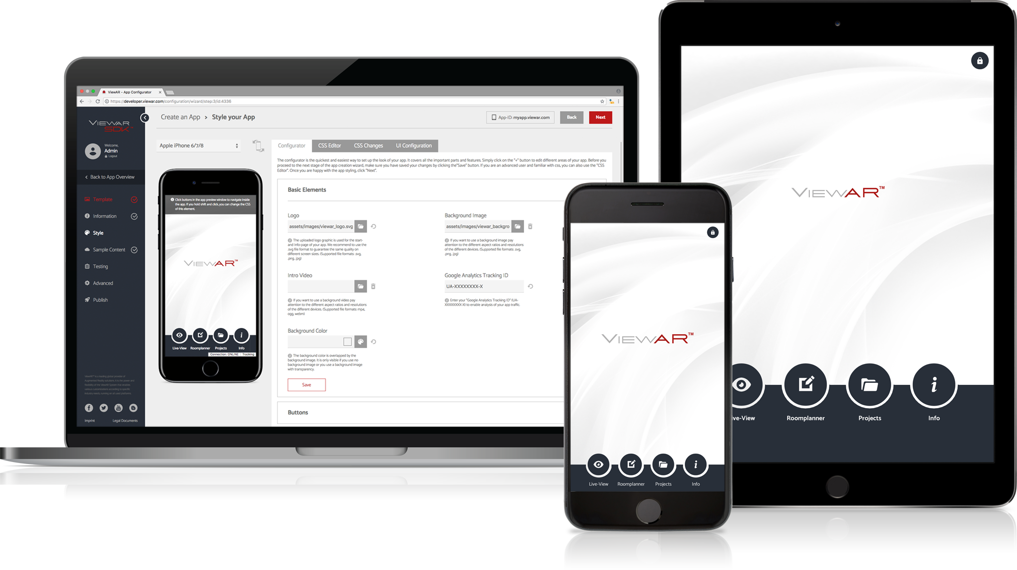

**5. Mapbox Augmented Reality SDK for React Native**

With this mixture of Mapbox and Reactnative, it is possible to build augmented reality enabled indoor navigation for mobile devices.

**6. Mapbox Vision SDK**

A comprehensive open source SDK for Augmented Reality vision for mobile devices. Expected beta release on September 2019. Now alpha release available for developers enabling to build AR vision apps. This is also enriched with Artificial Intelligence.

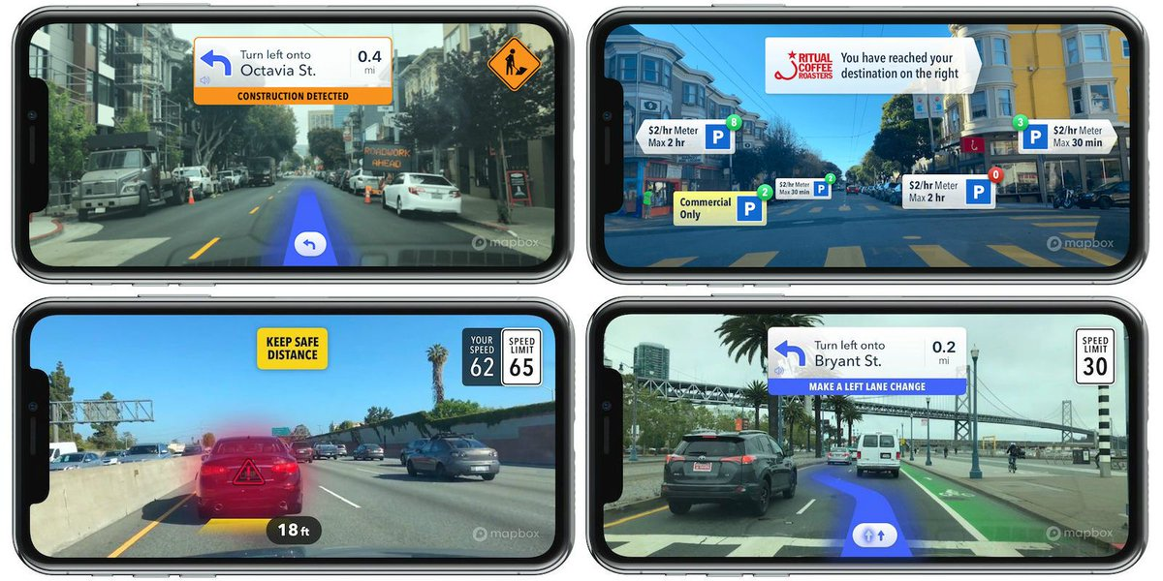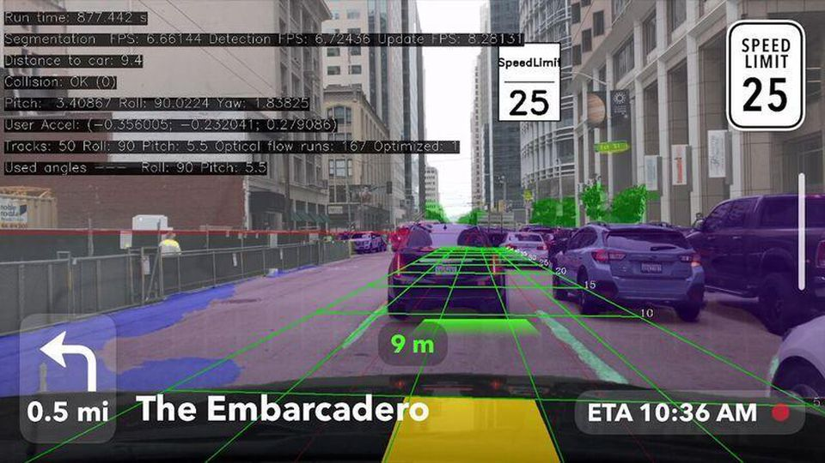

Demo video link: Mapbox Vision

<https://youtu.be/9FFMJ1Xa7TQ>

# ***Related Open Source projects from github:***

1. <https://github.com/wai25/Ustar>
2. <https://github.com/appoly/ARCore-Location>
3. <https://github.com/bonoj/ThirdEye>
4. <https://github.com/KrishAmal/NavAR>
5. <https://github.com/meizano/ARlibraryNavigation>
6. <https://github.com/hnekhniadovich/Indoor-Navigation-ARCore>

# **Software & Dependency requirement:**

1. Unity3D & Visual Studio
2. Android Studio & SDK, JDK, NDK
3. Visual Studio Code
4. GIT for windows
5. Python and JS dependencies